# **Want to learn more about Loss Aversion?**

﻿﻿

Learn more about the theory of loss aversion [here](https://insidebe.com/articles/loss-aversion/).  
 ﻿﻿

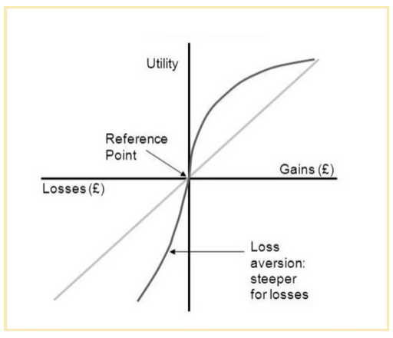

Graph depicting the psychological value of gains and losses.  
﻿﻿Source: [Researchgate](https://www.researchgate.net/figure/Cumulative-Prospect-Theory_fig1_348339300)

﻿﻿

See how the value curve is steeper on the loss (left) side than on the gain side? That is loss aversion.

﻿﻿

﻿﻿  
﻿﻿